

All work Copyright ©2013 by .

Written by

Version # 1.00

Friday, January 23, 2015

Table of Contents

Design History 4

Version 0.10 4

Version 0.20 4

Version 0.30 4

Version 0.40 4

Version 1.00 5

Game Overview 6

Philosophy 6

Common Questions 6

What is the game? 6

Why create this game? 6

What is the purpose of the game? 6

Where does the game take place? 6

What do I control? 6

How many characters do I control? 6

What can the character do? 6

How many levels are there going to be? 6

Do I score points? 6

Are there any obstacles or traps in the game? 7

What is the main focus? 7

What’s different? 7

Feature Set 8

General Features 8

Game Play 8

The Game World 9

The Streets 9

The Physical World 9

Key Locations 9

Travel 9

Scale 9

Objects 9

Day and Night 9

Time 9

Overview 10

2D/3D Rendering 10

Camera 10

Overview 10

Game Engine 10

Overview 10

Game Engine Detail 10

Collision Detection 10

Lighting Models 10

Overview 10

The World Layout 11

Overview 11

World Layout Detail 11

Game Characters 12

Overview 12

Enemies 12

User Interface 15

Overview 15

User Interface Detail #1 15

User Interface Detail #2 15

User Interface Detail #3 15

Weapons 16

Overview 16

Weapons Details 16

Musical Scores and Sound Effects 17

Overview 17

Red Book Audio 17

Sound Design 17

Music Play List 17

Single-Player Game 18

Overview 18

Single Player Game Detail #1 18

Story 18

Hours of Game play 18

Victory Conditions 18

“The First Ideas Appendix” 19

“In or Out Appendix” 19

“Who Did What?” 19

The First Ideas Document 20

General Setup: 20

Plotline: 20

Storyline: 20

Bonus idea: 20

In or Out Appendix 21

In the game 21

Not in the Game 21

Who Did What? 22

Mauk Buursink 22

Sjef van Doorn 22

Paul Dalessi 22

Sietse Dijks 22

# Design History

This is a brief explanation of the history of this document.

## Version 0.10

Version 0.10 is the first version of this design document. It includes the general setup and ideas about our game.

Here we did our thinking of how we wanted to do the game and how we where going to do it.

## Version 0.20

Here we did some design of the levels.

The design of the characters.

Thinking of the story

Began with gameplay

Began with the menu.

Trying to get the wii mote working

## Version 0.30

Trying to get the wii mote working

Added the design of the characters.

Added the story

Added with gameplay

Added with the menu.

## Version 0.40

Trying to get the wii mote working

Put some things together

A little bit of gameplay

Enemy’s making

Making background

## Version 1.00

Some final art of enemy’s

Some final gameplay

Some final art of background

Put the game together

Game Overview

## Philosophy

This game will be just for fun. It is meant for entertaining and fun for children around the age of 9. We want to have a variation of the old game called Duck Hunt.

## Common Questions

### What is the game?

The game is going to be a shooter. The game is going to look like Duck Hunt but then we have our background and our enemy’s.

### Why create this game?

We are creating this game because we got a assignment to make this sort of game.

### What is the purpose of the game?

The purpose of the game is to entertain the age group where we have designed this game for.

### Where does the game take place?

It is in a dream world of a men called Devin.

### What do I control?

The player will control a catapult.

### How many characters do I control?

You do control 1 character and that character has a catapult and you must shoot with the catapult..

### What can the character do?

The character can do nothing except the character can shoot with a catapult.

### How many levels are there going to be?

There are 10 levels.

### Do I score points?

You can score points to kill the enemy’s that are on the screen.

### Are there any obstacles or traps in the game?

No there will be no traps or obstacles in the game.

### What is the main focus?

The main focus of the game is that you shoot the enemy’s and then you survive you nightmares. And it is the mission that you survive your nightmares.

### What’s different?

The difference with other games is that this game is fun for everyone. And we have like a level system in our game that other games don’t have.

# Feature Set

## General Features

Self-constructed backgrounds.

10 different enemy’s.

10 different levels.

Three difficulty levels.

Mouse controls.

Keyboard controls.

Options menu.

## Game Play

Easy to control.

Easy to learn.

Easy to aim.

Run smooth.

Fun story you read.

# The Game World

## The World

In the game the player is Devin and he is in his room and it is night time and he falls asleep. Devin has nightmares and that are the levels. He must defeat the enemy’s before the times runs out to come out of that nightmare. If he doesn’t do that the will be trapped in that nightmare.

## The Physical World

### Key Locations

The key location is in Devin’s room because he has the nightmares. But it is also the levels that you play through.

### Travel

The player moves just from level to level. If you have won level one there comes an intro for level 2 and a different background and different enemy.

### Scale

We don’t have like a scale because it is imagination and we just have the enemy’s not to big and not to small just how they are.

### Objects

There are no objects in our game that you can pick up and use. Our object is like the rock that you shoot with and the enemy’s that fly. But we don’t have really object that you can pick up.

### Day and Night

The game takes place in a dream world. So Devin is sleeping but you play in a dream world.

### Time

The game will be in the dream world.

**Rendering System**

### Overview

Give an overview of how your game will be rendered and then go into detail in the following paragraphs.

### 2D/3D Rendering

We making this in xna game studio. This is a 2D engine and it is easy to learn.

## Camera

### Overview

The camera is set that you only see the enemy’s, the rock that you shoot, the timeline, the score and the background.

## Game Engine

### Overview

The game will be build in xna game studio.

# The World Layout

## Overview

The game world is a dreamworld. It are just pictures in the background that must be a location in the dream.

## World Layout Detail

This is the background for level 1.

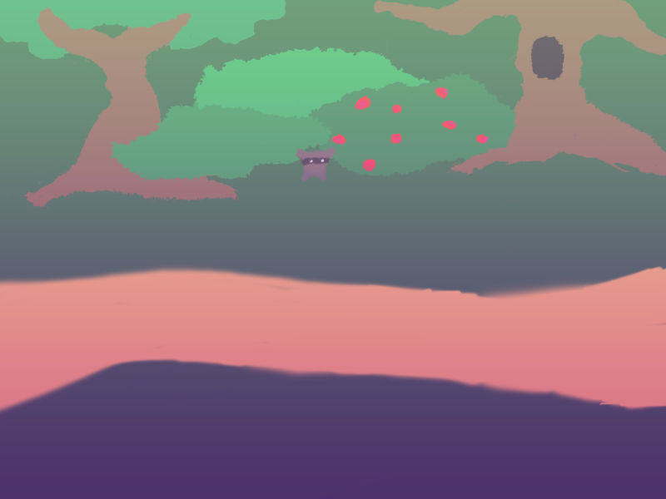

This is the background 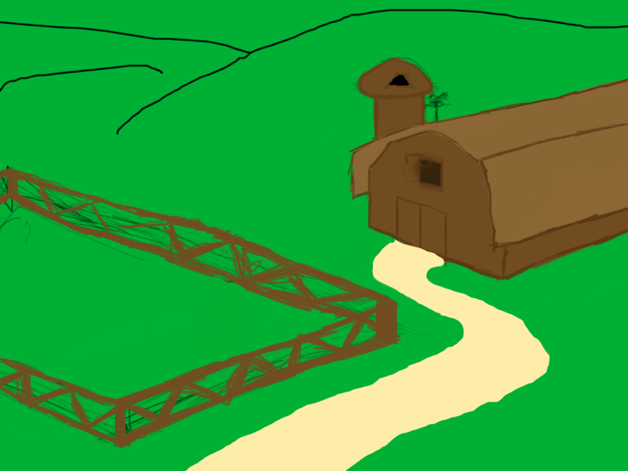for level 2.

This is the background for level 3.

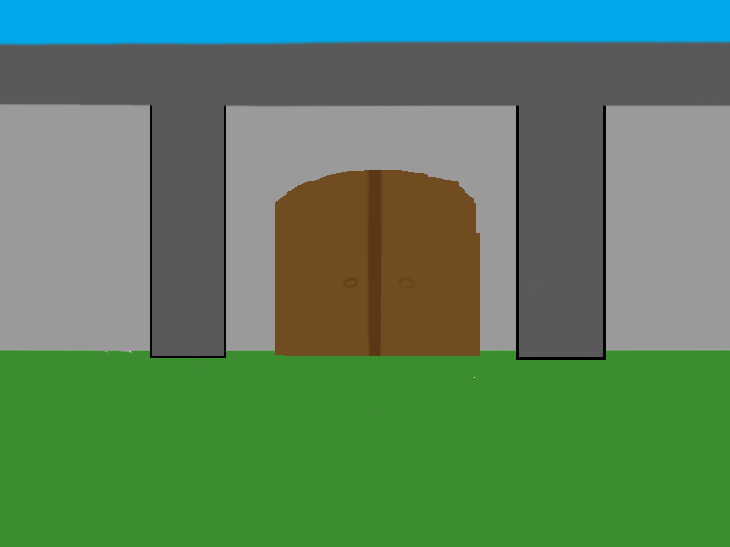

This is the background for level 4.



This is the background for level 5.

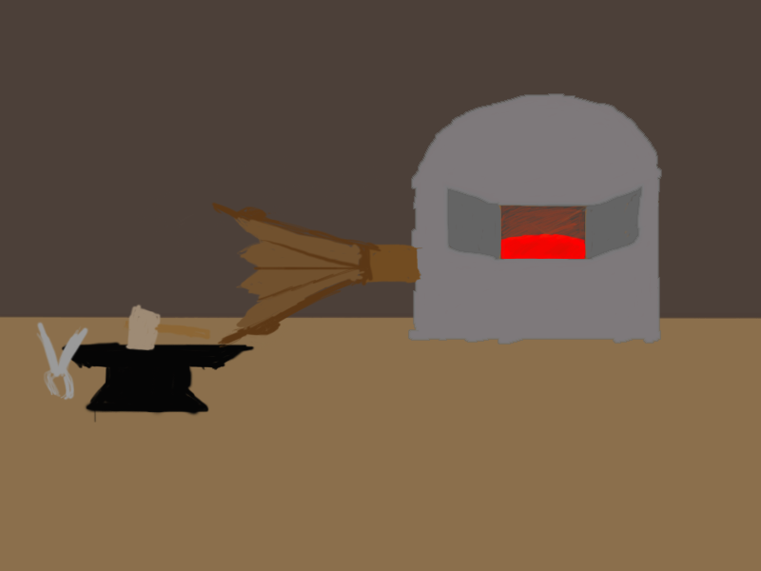

This is the background for level 6.

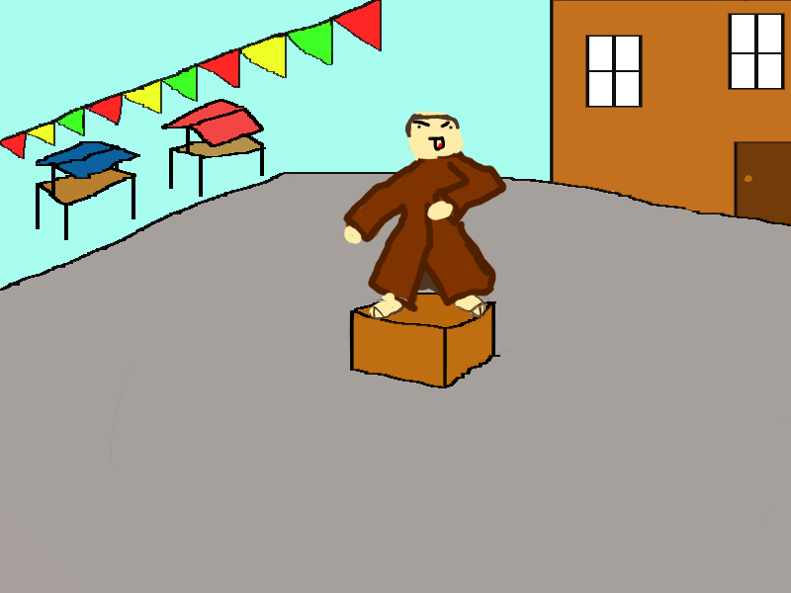

This is the background for level 7.

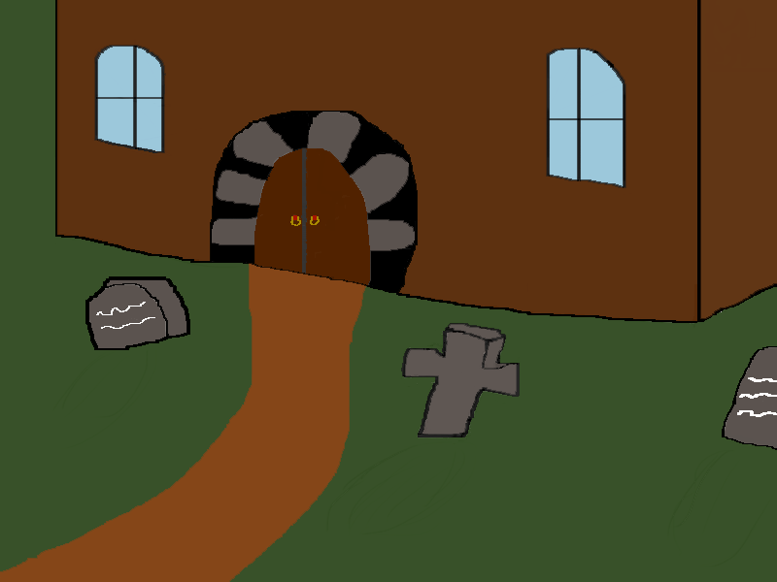

This is the background for level 8.

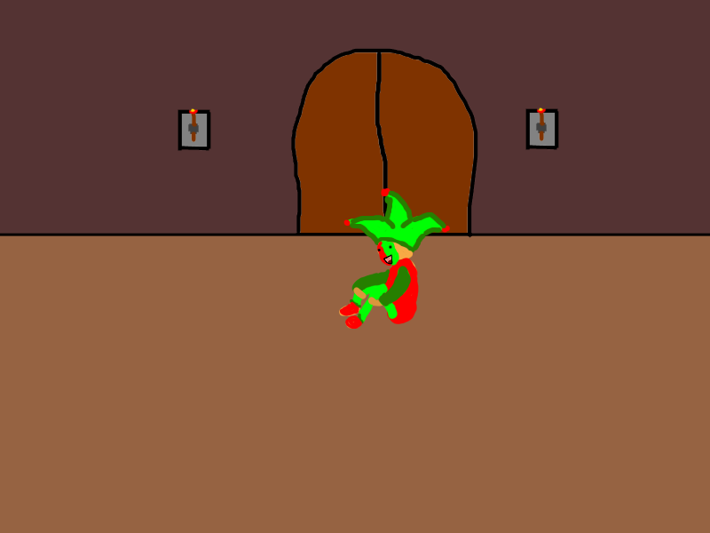

This is the background for level 9.

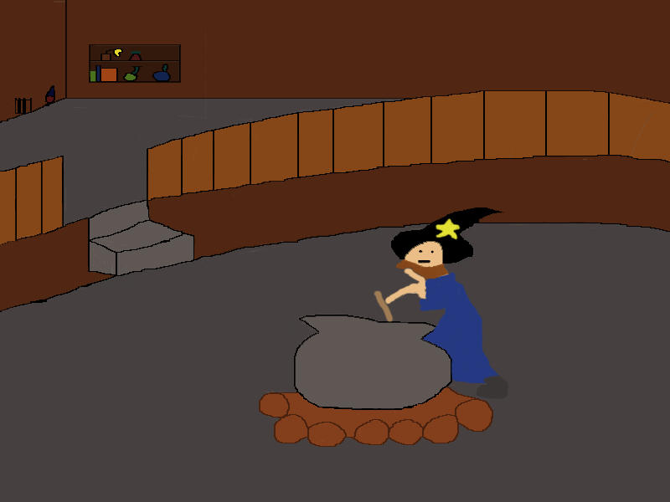

This is the background for level 10.

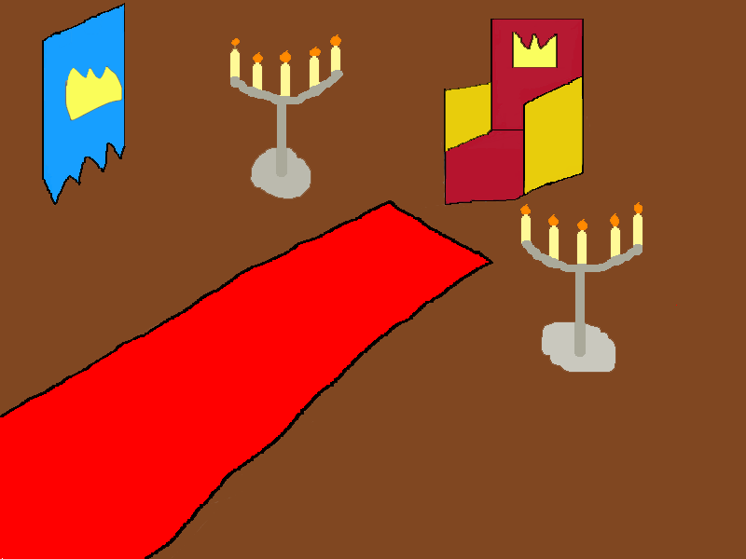

# Game Characters

## Overview

This game has just one main character and you don’t see him and is has multiple enemy’s.

**Main Character**

The main character’s name is Devin. He is just a boy that is going to sleep and then has nightmares. You control Devin and your mission is to get out of the nightmares.

## Enemies

# User Interface

## Overview

We have chosen for not too many details in the screen. Because we have a age group we designed this game for. Because it are children we don’t too many difficult things on the screen. We have unlimited ammo but you can’t shoot fast because the rock must disappear before you can shoot again.

## User Interface Detail #1

In the battle screen we have your score and a target score. You must have the get the target score before you can go to the next level.

## User Interface Detail #2

We have like a title screen with game, options, high score and quit. If you click on game you get a screen with what game type you want. And the you must choose your difficulty.

## User Interface Detail #3

You have in the options menu a couple of options. You can choose what you want to change in the game.

# Weapons

## Overview

We wanted to have the player one weapon. But we wanted the have multiple ammo’s but that didn’t go through. Now you can only shoot with a rock. The rock is slowly travelling because we didn’t wanted to beat this game easily.

## Weapons Details

Your weapon that you have is a catapult because that is want Devin has. You shoot with rocks because that is what he has.

# Musical Scores and Sound Effects

## Overview

## Red Book Audio

## Sound Design

## Music Play List

# Single-Player Game

## Overview

This is a single player game in a dreamworld. The player has to shoot to enemy’s with a catapult and that catapult’s ammo is a rock. The mission is to get out of the dreamworld and get awake.

## Single Player Game Detail #1

You don’t see the character but there is a feeling that you are the player because in the story you speak as the player and there is a feeling that you are the player.

## Story

The story in this game is that you come in a dreamworld and that the player: Devin has nightmares. He has to fight the enemy’s in his nightmares. He need to defeat all the enemy’s to get out of the nightmares. If he doesn’t defeat them he will be trapped in his nightmares and that is not good.

## Hours of Game play

The length of this game will be about five to ten minutes.

## Victory Conditions

The player will win if he defeats the boss of his nightmares.

# “The First Ideas Appendix”

In this appendix you will find our very first concept for this game. It is just us brainstorming about what we wanted to see happening and us thinking about the story.

# “In or Out Appendix”

In this appendix you will find an overview of the things we got into the game and things that had to be left out due to time or technical constraints.

# “Who Did What?”

This will be an overview of who did what in the game.

# The First Ideas Document

## General Setup:

We get the assignment to make a variation for duck hunt. So we did that and made one. We wanted to make multiple levels and have a story line because we liked that.

## Plotline:

## Storyline:

## Bonus idea:

# In or Out Appendix

In this appendix we will describe the things that made it in to the game and things that we had to leave out or skip.

## In the game

Ten enemy’s

Player

Catapult

Shoot with rocks

Main menu screen

Ten different backgrounds

Enemy’s animation

Score

High score

Mouse aiming

## Not in the Game

Music

Sounds

WII mote

Smart enemy’s

More then one weapon

That you can see the player

# Who Did What?